Congratulations on your decision to apply for
Camp Oh Ah Lay Lay’s
Program Aid in Training Leadership program.

We wish you the best of luck! To help you we have created a check list to make sure that you complete everything and have the best chance of being accepted into this leadership program.

As a reminder if your would like to be at camp no matter what…(and who wouldn’t) ~ have your parent put camper as your second choice so that we save you a spot.

- This application is the 1st step in becoming a Program Aid in training at Camp Oh Ah Lay Lay. This application is due no later than April 15th, 2022.
- Ask someone that knows you to write a letter of recommendation. Remind them of the deadline, and either give them the email or camp mailing address. Follow up to make sure it was sent in. They can email it directly to campohahlaylayregistrar@gmail.com. Have them use your name as the subject line.
- Have a back up plan if your person becomes too busy.
- Make sure to check your provided email address.
- Mail application and registration form to:
You will receive email confirmation when your application & registration form has been received.
Camp Oh Ah Lay Lay
c/o Bam-Bam
PO Box 1135
Eatonville, WA 98328

- You will be notified by May 1, 2021 the decision made on whether you have been selected to join our PAT program.
- PATs will join us for part of the PA/PAT retreat / training May 20-22, 2022, and will receive the council led PAT. Training. They will be considered PA trained for future consideration. In order to earn and wear the pin you must also complete your LIA before camp. The pin is not required to be considered as a future PA. Please see the website for more details.

We are excited to have you join the leadership team! Be YOU and Good Luck!!

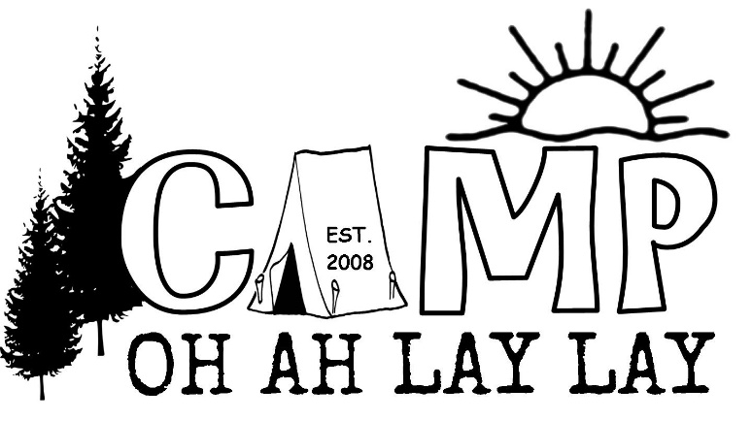

CAMP OH AH LAY LAY
Program Aid in Training (PAT)
Application
Contact Info:
Name: |  | Click or tap here to enter text.
Camp Name: |  | Click or tap here to enter text.
Age: | Click or tap here to enter text. | Grade | Choose an item. | School | Click or tap here to enter text.
Your Phone #: |  | Click or tap here to enter text.
Mailing Address: |  | Click or tap here to enter text.
Parents Name: |  | Click or tap here to enter text.
Parents Phone: |  | Click or tap here to enter text.
Parents Email: |  | Click or tap here to enter text.

Social Media Accounts:
Facebook | Click or tap here to enter text.
Snapchat | Click or tap here to enter text.
Instagram | Click or tap here to enter text.
Twitter | Click or tap here to enter text.
Any other Social media profiles. Please list here: Click or tap here to enter text.

Questions:
How many years have you been in Girl Scouts?
Click or tap here to enter text.

Have you attended Camp Oh Ah Lay Lay before? When? Who were your leaders?
Click or tap here to enter text.

Have you attended any other Girl Scout camps? (Day or overnight) When? Which ones?
Click or tap here to enter text.

Have you attended any other camps (Day or overnight) other than Girl Scouts? When & Where?
Click or tap here to enter text.

What were some of your favorite/most memorable moments about your past camp experiences?
Click or tap here to enter text.

What were some of your least favorite moments about your camp experiences?
Click or tap here to enter text.

Tell us about your favorite camp leaders and what you liked about them?
Click or tap here to enter text.

What is your favorite part of being a Girl Scout?
Click or tap here to enter text.

Tell us about the times when you have been in a leadership position, or a time you had to be in charge.
Click or tap here to enter text.

What do you think it means to be a leader?
Click or tap here to enter text.

What is your opinion of the behavior of each GS group? Describe in three word for each.
Daisy: | Click or tap here to enter text.
Brownie: | Click or tap here to enter text.
Junior: | Click or tap here to enter text.
Cadette: | Click or tap here to enter text.
Senior: | Click or tap here to enter text.
PAT: | Click or tap here to enter text.
PA: | Click or tap here to enter text.
Unit Leaders: | Click or tap here to enter text.
Thumper: | Click or tap here to enter text.
Scrappy: | Click or tap here to enter text.

What age group do you think you would like to work with and why?
Click or tap here to enter text.

Why do you want to go through the PA training?
Click or tap here to enter text.

Tell us something that you are really good at:
Click or tap here to enter text.

Tell us something that you could work on:
Click or tap here to enter text.

What Would you do if:
A camper told you your activity/craft was the worst ever?
Click or tap here to enter text.

Another PAT bossed you around…
Click or tap here to enter text.

You heard someone was talking about you behind your back at camp?
Click or tap here to enter text.

You thought someone at camp didn’t like you
Click or tap here to enter text.

You heard another PAT talking inappropriately.
Click or tap here to enter text.

You didn’t like someone in your PAT unit, or a unit you were assigned to as a leader?
Click or tap here to enter text.

You were told you would have to repeat the PAT training next year.

Click or tap here to enter text.

I understand that the PAT program will include training to be the best GS leader I can be. I am camp as a Program Aid in Training to open my eyes, my heart and my mind to new strategies of leadership, new age groups, and different personalities.

I understand that even though I completed a one-week camp PAT training I may not be accepted into the PA program the following summer. I may instead be asked to return for another week of PAT training the following summer.

My behavior at Camp Oh Ah Lay Lay will reflect the Girl Scout Law. I understand that if my behavior at camp does not reflect the Girl Scout Law, I may not be able to complete the PAT training in a timely manner.

I understand that bullying will not be accepted at camp, and if I choose to participate, I will be asked to leave the leadership program here at Camp Oh Ah Lay Lay.

I understand that I represent the Girl Scouts at all times, even when not at camp. My actions on social media included. My social media will be checked by my leaders. All of my online behavior will at all times reflect the proper Girl Scout Laws.

I agree that this application is true and all statements are my honest opinions, facts and memories.

Signed | Click or tap here to enter text. | Date | Click or tap to enter a date.

